Introduction to FCS – Course Outline - Spring 2015
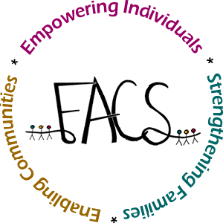
Miss Schneck

Chapter 23 Looking at Housing Choices
Chapter 24 Understanding the Art of Design
Chapter 25 Making Designs Work for You

Chapter 38 Nutrients and their Functions
Chapter 39 Guidelines for Healthful Eating
Chapter 42 Planning Meals and Snacks
********** Principles of Baking
********** Quick Breads
Chapter 49 Fruits and Vegetables
********** Cookies and Cakes
Chapter 52 Etiquette and Eating Out

Chapter 12 Looking at Families
Chapter 13 Building a Strong Family
Chapter 14 Handling Challenges
Chapter 15 Understanding How Children Grow
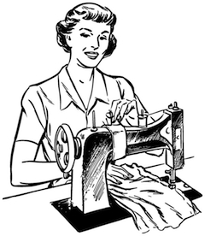
Chapter 16 Taking Care of Children
Chapter 17 A Look at Parenting

Chapter 28 Selecting Clothing
Chapter 29 Fibers to Fabrics
Chapter 30 Caring for Clothing
Chapter 33 Sewing Equipment
********* Sewing Samples/Project

Chapter 7 Exploring Careers

Teacher: Miss Schneck
Textbook: Today’s Teen
Materials needed: * 1 1/2 – 2 in. ring binder, (Suggested)
*Colored ink pens or fine line markers (Suggested)
*Highlighters

Course #22201A001 (HE01)

