PARENTING: Course Outline/Spring – 2015



**Ch. 1 What is Parenting? *Don’t you just know how?***

# Ch. 2 Role of the Family

**Ch. 3 Rewards and Responsibilities  *Are you ready?***

**Ch. 4 Personal Readiness**

**Ch. 5 Teens and Parenting**

# Ch. 6 Effective Parenting Skills *What will be your “parenting style”?*



**Ch. 7 Planning a Family. *Conception and Misconception.***

# Ch. 8 Pregnancy *And now we wait, dream, plan.*

# Ch. 9 A Healthy Pregnancy *Building the dream.*

# Ch. 10 Preparing for Baby’s Arrival

**Ch. 11 The Birth Process *Special delivery—The Big Event!***

**Ch. 12 Adapting to Parenthood *Now what do I do?***



**Learning about your child……..**

**Ch. 14 Parenting Infants**

# Ch. 15 Health and Safety

**Included in the Baby Book**

# *Ch. 13 Understanding Infants*



***Ch. 17 Helping Children Develop Emotionally***



## Ch. 18 Helping Children Relate to Others

***Ch. 19 Helping Children Learn***

**Ch. 16 Helping Children Grow & Develop**

**Physically**

**Ch. 28-30 Child Care and Education Options**

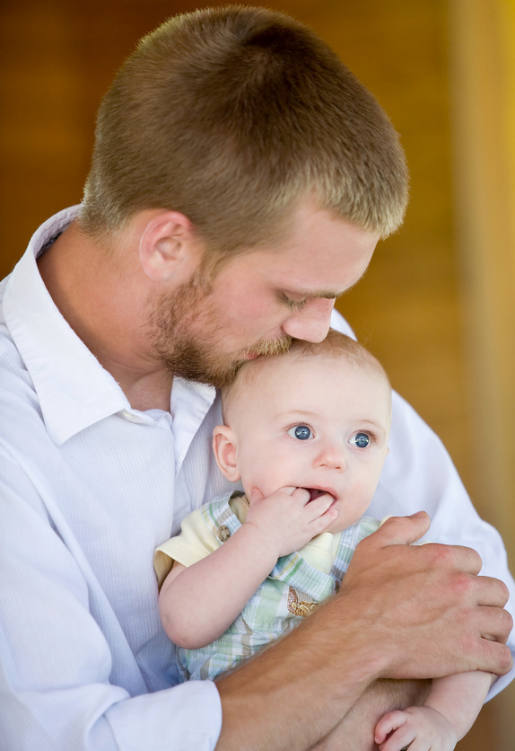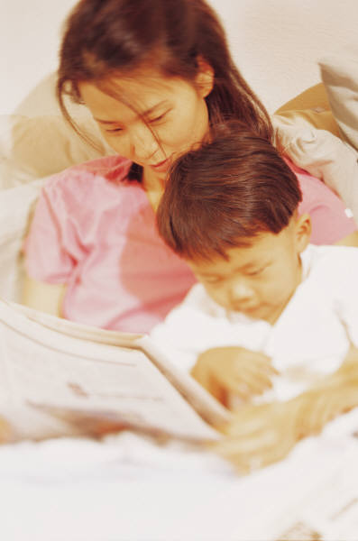

**Ch. 22 Encouraging Children**

**Ch. 23 Guiding Moral Development**

**Ch. 24 & 25 Guiding Children’s Behavior**

**Handling Common Problems**

**Ch. 21 Children with Special Needs**

**Teacher: Miss Schneck**



# Textbook: Parenting: Rewards and Responsibilities

**Materials Needed: 1 ½ - 2 inch ring binder, (Suggested)**

**Colored ink pens or fine line markers**

**(suggested for notes and class activities)**

**Have a Great Semester ! ! ! ! ! ! ! ! !**